**Contentia.io - Kagan Sahin & Suad Khan**

This document consists of product requirements and agreement for the Contentia Platform on Upwork between Kagan Sahin and Saud Khan.

Based on the provided specifications in the meetings and below document, including the major functionality such as order management, UGC packages, single orders, custom orders, and payment integration, we agree on the complete development cycle which will take up to to 5 months.

This timeline covers all aspects of the project, including front-end and back-end development, deployment, and rigorous testing.

To ensure the highest quality and efficiency, we anticipate the following breakdown: 1. Web Platform Development: Approximately 3 months

Customer Panel: 1 month

Creator Panel: 1 month

 Admin Panel: 1 month   
2. Mobile App Development: (iOS & Android) Approximately 1 to 2 months

Creator Panel: 1-2 months

Next.js and React.js will be used as Frontend technologies, while Node.js will be used for the Backend. For the database, Mongo DB will be used as agreed. Mobile Applications and Web Platform will use the same Admin Panel for the project.

This Platform will be in Turkish, therefore the contents and texts will be delivered by the client.

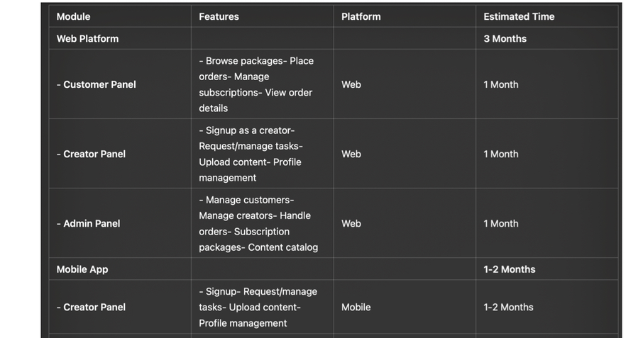



Contentia is a marketplace platform, where customers purchase UGC videos and images from the creators.

Customers will choose one of the purchase methods, and receive their UGCs created by the Creators.

Creators are individuals who would like to signup Contentia as Creator. They will be able to request the tasks ordered by the customers. If approved by the Platform, they will generate content for customers and upload the final document via the Mobile App.

Creators will be able to fill-in “Become a Creator” form on the web and mobile app. Creator panel will be available on the mobile app, where creators view, request and complete the orders of customers. There will be 2 types of Creators on the platform (Micro / Mega), explained in detailed later in this document.

There will be 3 types of orders on the platform.

**1- UGC Packages:** Customers choose one of the 3 different packages, and get their service within 1 month.

**2- Single Order:** Customers can create their own package, based on the number of UGC needed, at a fixed price. Customers will be able to add additional services and pay the full amount.

**3- Custom Order:** Customers can fill-in the contact form to request a special offer. Admin panel should include custom order (i.e Creating custom orders on the Admin Panel and give coupon codes for special offers.)

There are 4 different pre-defined packages available on the platform. Customers will either choose one of the pre-defined packages for a special discount or select their orders as shown: https://sedalms.my.canva.site/contentiaio

**1- Starter:** Starter package includes 3 User Generated Content that will be delivered within 1 month. Package include 3 UGC Videos 15 seconds, with aspect 9:16 by default. Price Package will show additional services, if selected the package detail will be changed

**2- Launch:** Launch package includes 6 User Generated Content that will be delivered within 1 month. Package include 6 UGC Videos 15 seconds, with aspect 9:16 by default. Price Package will show additional services, if selected the package detail will be changed

**3- Growth:** Growth package includes 12 User Generated Content that will be delivered within 1 month. Package include 12 UGC Videos 15 seconds, with aspect 9:16 by default. Price Package will show additional services, if selected the package detail will be changed

**4- Custom:** Custom packages will be created on the Admin Panel based on the customer needs. Admin will be able to insert X amount of UGC, charging Y Turkish Lira

**Web Platform Index**

1. Landing Page   
2. Login / Signup   
3. Become a Creator   
4. Customer Panel

Profile (Full Name / E-Mail / Contanct Information (Address / Phone Number) / Invoicing Details )

My Brands

Create Brand

Orders (All / Active / Completed / Not Started / Cancelled)

 Order Details (Date / Status / Files)   
5. Purchase

Order Details

Payment (İyzico)

Video Brief

 Creator Preferences   
 6. Help & Faq   
A blog-like page to give information about the platform, tips about the contents etc.

For Customers

For Creators

**1 - Landing Page:**

|  |  |
| --- | --- |
|  | https://sedalms.my.canva.site/contentiaio https://billo.app/ |

**2 - Login —> For businesses & Customers**   
https://manage.billo.app/login?

_gl=1*10vmb0c*_gcl_aw*R0NMLjE3MjE4MjUyMDYuQ2p3S0NBand6SUsxQmhBdUVpd0FIUW1VM2lRaS1RSDhaQjhER TYwbm01b3BQVXhYRkhyZG1pZ3N0SzhXUHhQaENzX080VGhjaUhNSGpob0MtWkVRQXZEX0J3RQ..*_gcl_au*MTc4M TM3Nzg4Ni4xNzIxODI1MjA0*FPAU*MTc4MTM3Nzg4Ni4xNzIxODI1MjA0

**3- Become a Creator (Editable from Creator Panel)**   
Creator panel will be available both on Web Platform & Mobile App. Creators will be informed that Creator panel is only available on mobile app, so once the Become a Creator form filled-in, users will be redirected to downlaod the application (Ex: https://billo.app/for-creators/)

All the information inserted in Become Generator Form will be editable later on from the Creator Panel:—> Full Name(Only visible to platform)  
—> Social Media Usernames - Optional (Instagram / Facebook / TikTok/ Youtube / Other (Textbox))   
—>   
—> Revisions (info: In case brand request revisions for the video I accept remaking it)  
—> UGC Type (Select all that applies: Reels, TikTok, Instagram Post, Instagram Stories, Youtube Video, Other (Textbox)—> UGC Preferences (Select all that applies: Product / Service / Place) -

 info: Please select your UGC preferences:

 Product: The product will be shipped to your address for free and you will generate the relevant content.

 Service: Services will not require any shipment of products, you will access the service via internet and generate the relevant content.

 Place: You will physically visit the place that customer would like to promote and generate the relevant content.

—> In case Product / Place selected:  
—> Address (info: Please insert the address that customers will ship products)—> TCKN   
—> Invoicing (Yes / No)  
—> Creator Type (Micro / Mega)

 Micro: Creators may have any number of followers, and are expected to use a high-quality smartphone to shoot and edit UGCs

 Mega: Creators are expected to have +20k organic followers on at least one of the social media platforms. Creators are expected to have full equipment, such as camera, microphone, lighting equipment etc.

—>Social Media Posting (Yes / No)

 info: Select yes, if you want to share the posts you created on your social media accounts for an additional charge

**4- Customer Panel**   
Customer panel will be available solely on Web Platform. Users will be able to view packages and fees for the single video purchases, however if user would like to purchase, he must signup to the platform

|  |  |  |
| --- | --- | --- |
| Customers will include the following information: | | |
|  | Profile (Full Name / E-Mail / Contanct Information (Address / Phone Number) / Invoicing Details ) | |
|  | My Brands: Customer will be able to save any number of different brands by clicking on the Create Brand | |
| button | | |
|  | | Create Brand: Customer will add Brand Name, Brand Category, Brand Website and Country. |
| Ex: https://manage.billo.app/brands | | |
|  | Packages: If one of the packages are purchased, customer will be able to see their package and UGC orders | |
| used and left. | | |
|  | Orders: Customers will be able to see past orders with order details | |
|  | | Order Date |
|  | | Order Status (Active / Completed / Cancelled) |
|  | | Order Brief |
|  | | Order Scenario (if customer defined a scenario for the UGC |
|  | | Order Files (if the order is completed, Customer will be able to download the UGC from the panel |

**5- Orders (Get a Video)**   
Customers will click on the get a video button. In case, customer have purchased package, customer will be able to see how many UGC order left from the package.

|  |  |  |
| --- | --- | --- |
| Order Page will include 4 steps. (Ex: https://manage.billo.app/campaigns/new?page=new-form) | | |
|  | Order Details | |
|  | | Platform (Meta, Tiktok, Other (if other selected there will be aspect ratio option 9:16 or 16:9) |
|  | | Duration (15-30-60 seconds for different pricing) |
|  | | Editing (for additional charge) |
|  | | Number of Videos |
| Use my package  Select any amount of video | | |
|  | | Additional Features |
| Share Post  Cover Image  Subtitle  Logo  Royalty Free Music | | |
|  | | Choose Creator Type |
| Micro (Chosen Standard)  Mega (+X TRY) | | |
|  | Payment | |
|  | | Basket Summary |
|  | | Payment (İyzico) |
|  | Video Brief | |
|  | | Select Brand |
|  | | Add Video Brief |
|  | | Upload File (Logo, picture etc.) |
|  | | Add Scenario (Optional: Customer may add a scenario for the UGC; Ex: A person stucked in traffic, and |
| used a scooter etc.) | | |

**Creator App**   
**1- Login / Signup**   
In the mobile app, only creators will be able to login and signup

  **Become Generator (Editable from Creator Panel)**   
Creator panel will be available both on Web Platform & Mobile App   
All the information inserted in Become Generator Form will be editable later on from the Creator Panel:—> Full Name(Only visible to platform)  
—> Social Media Usernames - Optional (Instagram / Facebook / TikTok/ Youtube / Other (Textbox)) —> Paylaşım Tercihi + İçerik Üretici   
—> Revisions (info: In case brand request revisions for the video I accept remaking it)  
—> UGC Type (Select all that applies: Reels, TikTok, Instagram Post, Instagram Stories, Youtube Video, Other (Textbox)  
—> UGC Preferences (Select all that applies: Product / Service / Place) -

info: Please select your UGC preferences:

 Product: The product will be shipped to your address for free and you will generate the relevant content.

 Service: Services will not require any shipment of products, you will access the service via internet and generate the relevant content.

 Place: You will physically visit the place that customer would like to promote and generate the relevant content.

—> In case Product / Place selected:  
—> Address (info: Please insert the address that customers will ship products)—> TCKN   
—> Invoicing (Yes / No)  
—> Creator Type (Micro / Mega)

Micro: Creators may have any number of followers, and are expected to use a high-quality smartphone to shoot and edit UGCs

Mega: Creators are expected to have +20k organic followers on at least one of the social media platforms. Creators are expected to have full equipment, such as camera, microphone, lighting equipment etc.

—> Social Media Posting (Yes / No)

 info: Select yes, if you want to share the posts you created on your social media accounts for an additional charge  
—> Interests   
Please select your areas of interest, so that we can find you more relevant UGC tasks   
List of Areas of interest

**2- Browse Tasks**

View Brand and order description

 View Briefing and Brand Details   
**3- Request Tasks**

Creators will request UGC tasks, to complete the order. The number of task request is limited up to %50 more than the UGC amount purchased by the customer.

**4- Orders**   
4.1 - View Order details   
4.2 - Upload UGC to Customer Panel   
4.3 - Edit / Manage UGC Uploads   
4.4 - Edit Status of Order (Mark as Not Started / In Progress / Completed / Cancelled) **5- Push & E-Mail Notifications (New Task / Revision / Completed)**

**Admin Panel**   
Both web platfom and mobile app will be viewed and managed by the same admin panel.

**1- Customers**   
1.1 - Add New Customer   
1.2 - Edit Customer   
1.2.1 - Edit Profile   
1.2.2 - Edit Brands   
1.2.2.1 - Add Brand   
**2- Creators**   
2.1 - Add Creator   
2.2 - Approve Creator   
2.3 - Edit Creator Information   
**3- Orders**   
3.1 - New Order (Per piece)   
3.2 - Edit Order Packages (Price / No of Contents)   
3.3 - Cancel Order (Iyzico / Cancel Payment)   
3.4 - Creator Deliveries (View / Delete / Upload for Creators) 3.5 - Request Task   
3.6 - Edit Status of Order

**4- Catalogue**   
Pricing will be changed from the Admin Panel or Database. We need to be able to assign one price for single video and additional services such as editing, duration etc. A percentage of discount will be applied as the number of services increase.

Videos and images shall be editable from the panel.   
**5-Help & Faq**   
Add new topics   
Edit the order

**6- Contact Forms**   
Contact

**Landing Page - https://sedalms.my.canva.site/contentiaio**

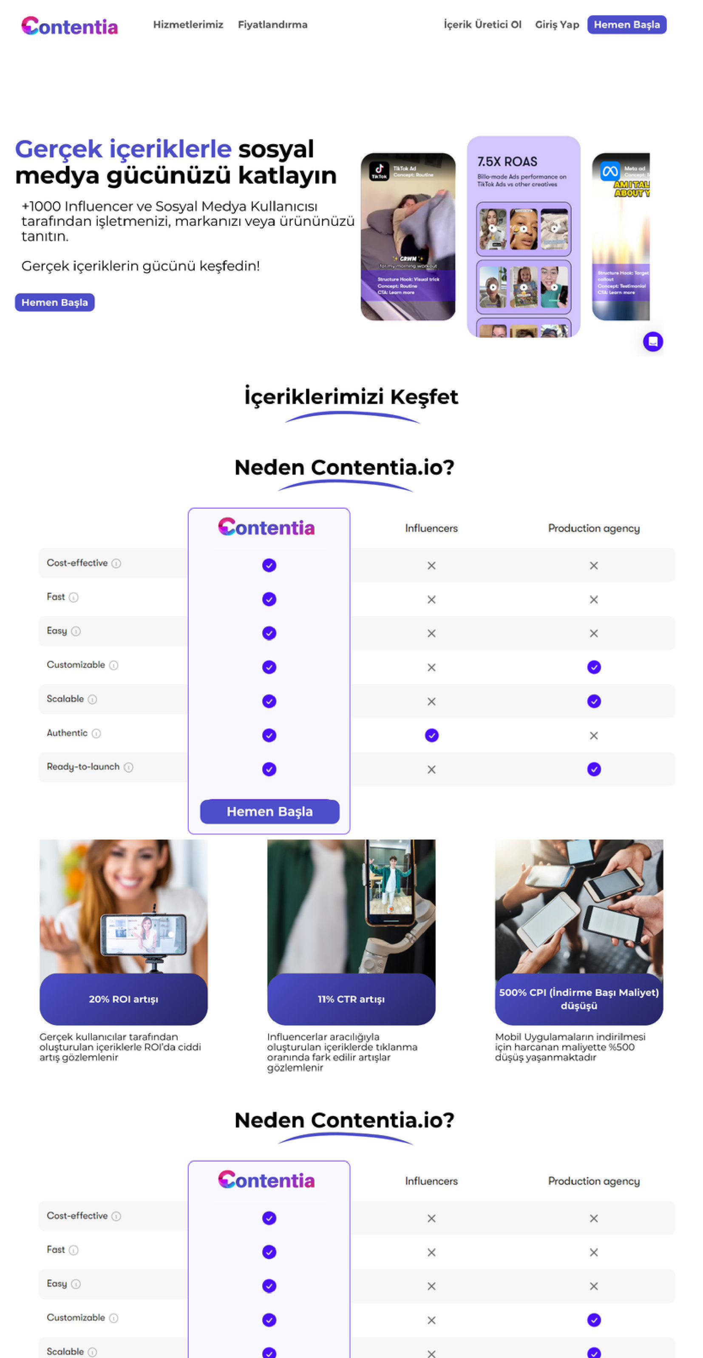

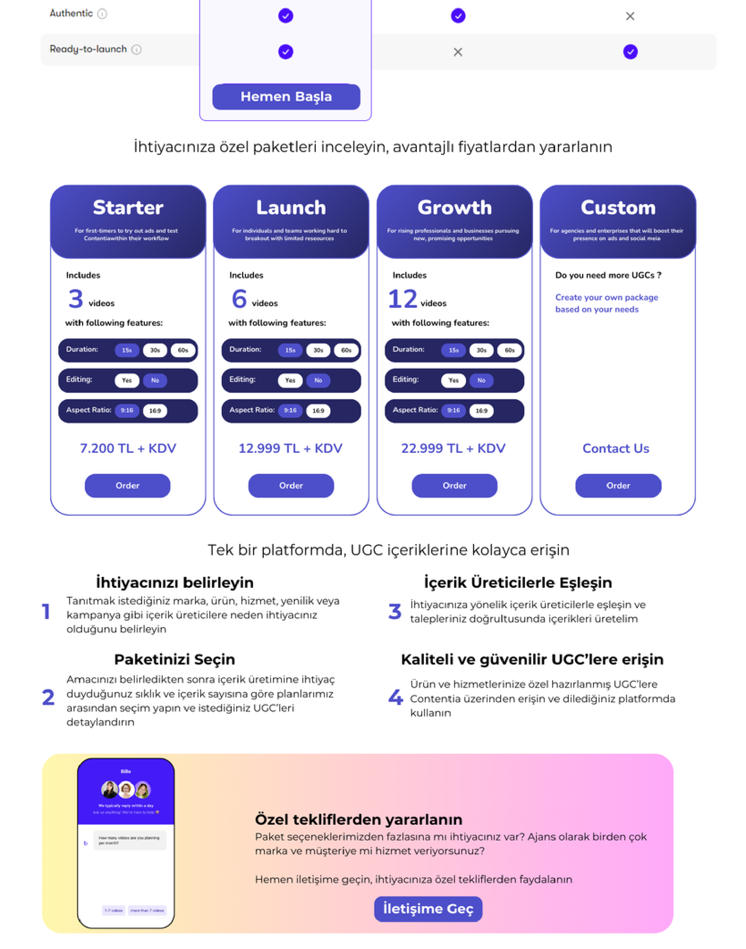

**Order Page - https://sedalms.my.canva.site/order**

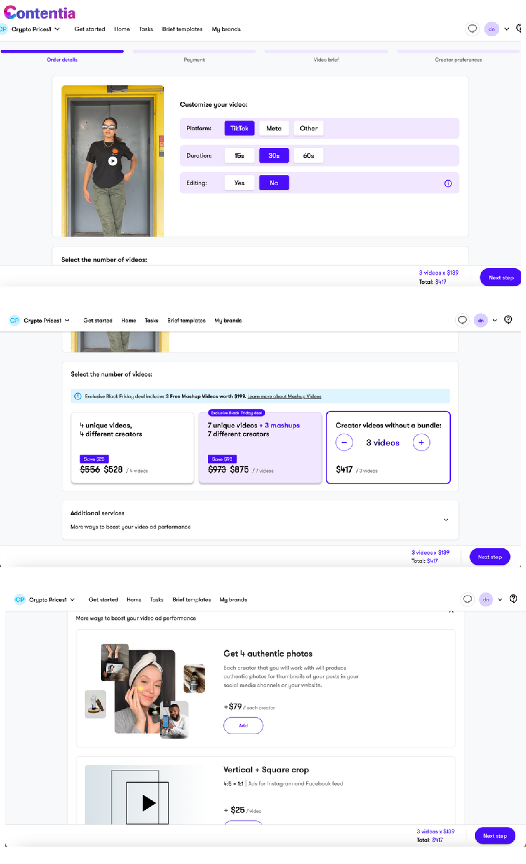

**Customer Panel - https://sedalms.my.canva.site/customerpanel**

